Brief content of lectures on
Discipline Physiological basis of plants productivity
L 1. Theme .Importance of agricultural productivity, its main components
Agriculture is a key activity of human being since it provides basic needs such as food, clothing and shelter. It has been demonstrated that every 1% increase in agricultural yield translates into a 0.6–1.2% decrease in the numbers of absolute poor households in the world.
Population growth was predicted to be 9.7 billion by 2050 and this will require an increase of about 70% in food production to meet the demand.
Rainfed agriculture produces one-third or more of the food increase in global food output for the coming decades.
However , agricultural productivity depends on increasingly extreme weather phenomena.
Thus, water availability, air pollution, and temperature have a large impact in agriculture
Agricultural productivity is an important component of food security.
Increasing agricultural productivity through sustainable practices is an important way to decrease the amount of land needed for farming and slow environmental degradation and climate change through processes like deforestation.
An increase in crop yields significantly reduces poverty.
Yield
Is measured in terms as total factor productivity (TFP). This method of calculating agricultural productivity compares an index of agricultural inputs to an index of outputs.
Agricultural productivity may also be measured as total factor productivity (TFP). This method of calculating agricultural productivity compares an index of agricultural inputs to an index of outputs. 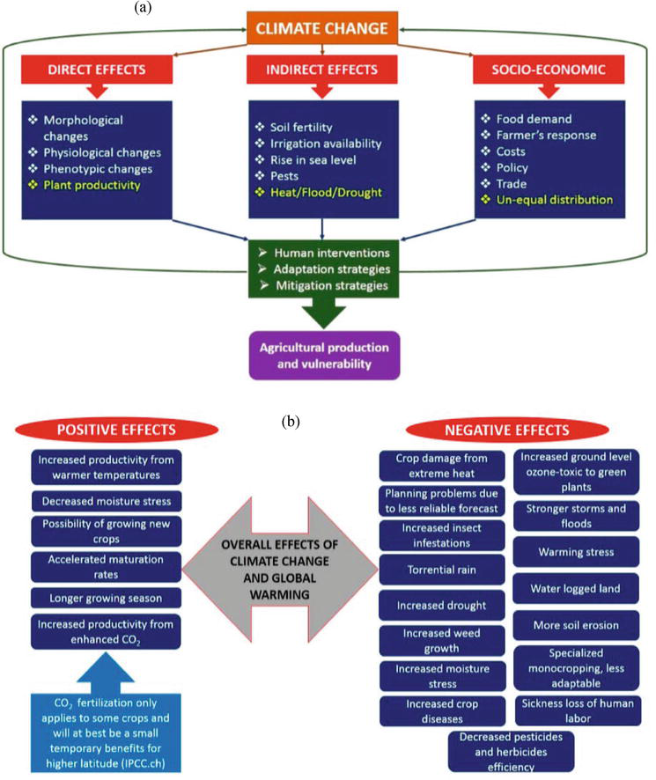

General effects of climate change in agricultural production

Lecture 2. Theme Photosynthesis and crop yield

Photosynthesis is an essential metabolic pathway for plants, contributing to growth and biomass production.

the efficiency by which a crop captures light and converts it into biomass over the growing season is a key determinant of final yield, be that biomass or grain.

The maximum yield attainable from a crop has been termed yield potential and can be defined as the maximum yield attainable when the best adapted crop variety is grown, in optimal conditions with no biotic or abiotic stress.

Determinants of yield potential are:
- light availability,
- light capture,
- energy conversion, and
- plant architecture.

For major crops, rice, wheat, and maize, the only one of these four components contributing to yield that is below the potential maximum is energy conversion, which is determined by photosynthetic efficiency.

However, the efficiency of this conversion of energy to harvestable biomass, given that as much as 50% of fixed carbon is lost to photorespiration under certain conditions, has yet to be adequately explored.

Photosynthesis integrates physiological responses:
- stomatal dynamics),
- environmental clues (e.g. light), and
- biochemical changes in the cell (e.g. sugar levels, redox poise, etc.).

Photosynthesis is affected by intra-plant and inter-plants factors, as well as environmental variables.

During Photosynthesis process, two photosystems work in series (Photosystem II -PSII- and Photosystem I -PSI-) harvesting light energy, which is then converted to chemical energy in the form of carbon organic molecules.

Plants photosynthesis occurs inside the chloroplast of photosynthetic organs, and the organic molecules produced by these organs are usually exported as sucrose to sustain the growth and maintenance of the non-photosynthetic tissues (e.g. roots, immature shoots, developing seeds, fruits) or to be stored as a carbon reservoir (e.g. tubers).

Therefore, photosynthesis is directly related to plant growth and, in agriculture, to crop yield.

Lecture 3. Theme Mechanism to improve efficiency of photosynthesis
Several strategies to improve the efficiency of photosynthesis have been proposed. Decreasing photorespiration, transforming C3 crops into C4,
- Optimization of Calvin cycle and electron transport are some of the mechanisms.
- Reducing light-harvesting antenna size, introducing components of algal CO2-concentrating mechanisms, engineering of photorespiratory bypasses, and
- accelerating recovery from photoprotection (NPQ) are strategies which are also recently proposed.
- Optimization of calvin cycle / rubisco-related targets
- Decreasing photorespiration,
- transforming C3 crops into C4,
- Optimization of Calvin cycle and electron transport.
- Reducing light-harvesting antenna size,
- introducing components of algal CO2-concentrating mechanisms,
- engineering of photorespiratory bypasses, and
- accelerating recovery from photoprotection (NPQ).

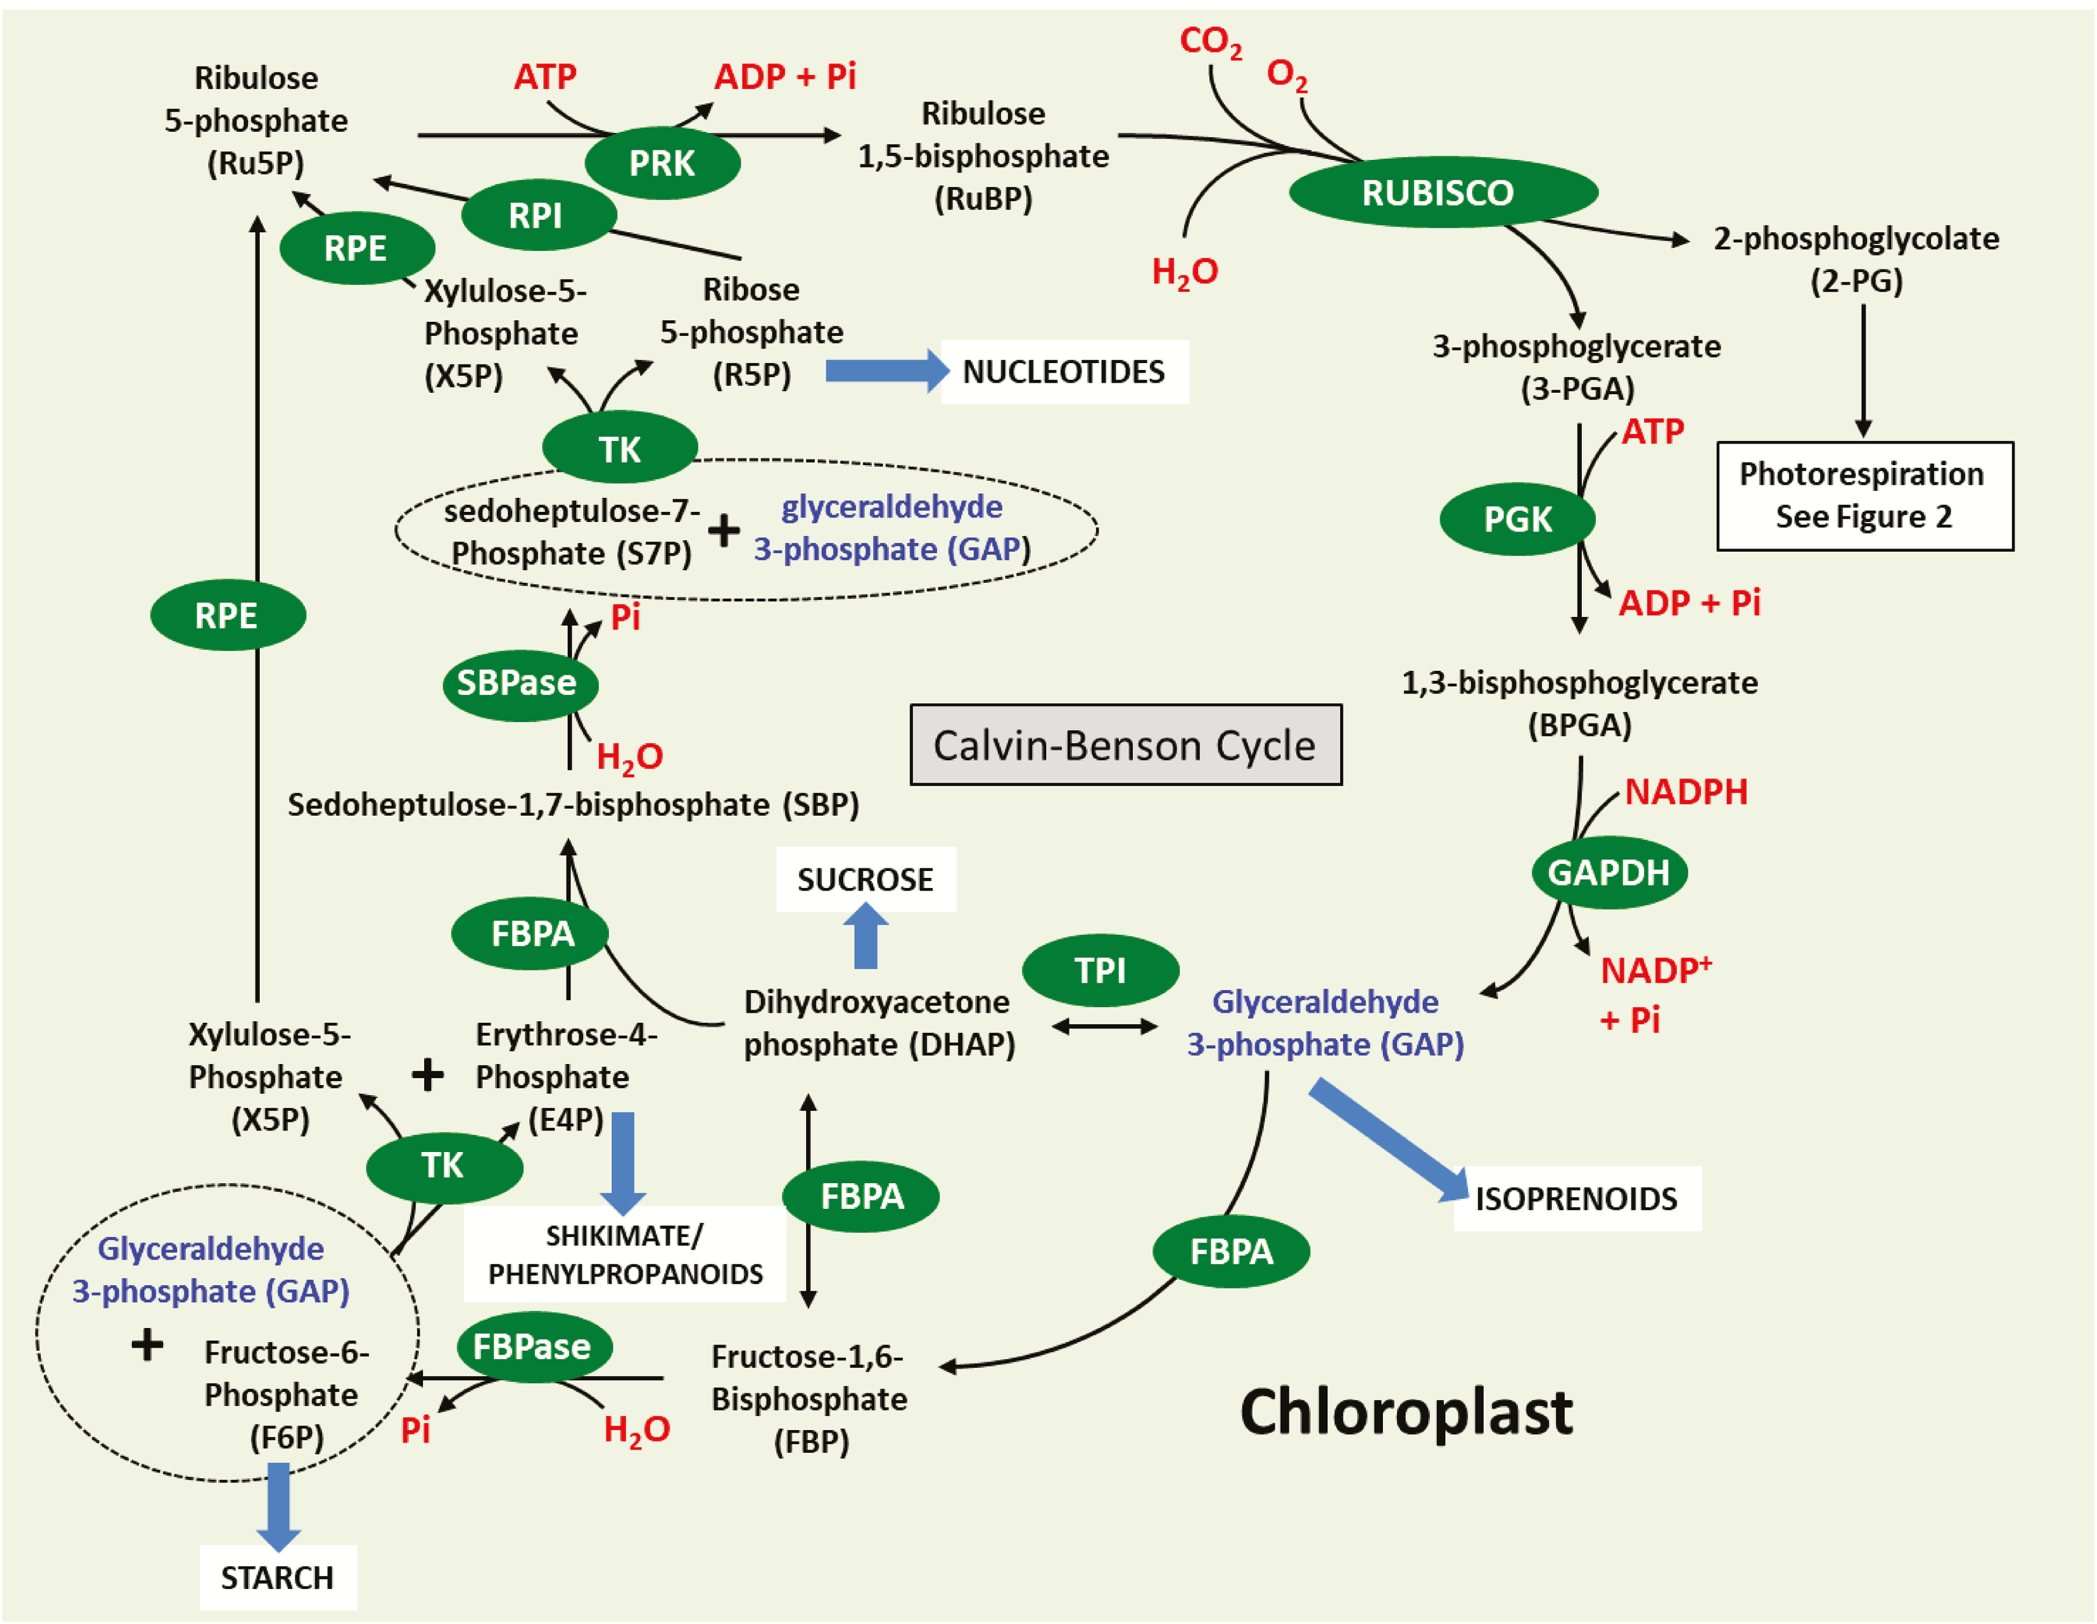 Fig. 1. Schematic representation of the Calvin–Benson cycle. Sedoheptulose-1,7-bisphosphatase (SBPase: EC 3.1.3.37), fructose-1,6-bisphosphate aldolase (FBPA: EC 4.1.2.13), fructose-1,6-bisphosphatases (FBPase; EC 3.1.3.11), transketolase (TK; EC 2.2.1.1), phosphoribulokinase (PRK; EC 2.7.1.19), ribulose-phosphate 3-epimerase (RPE; EC 5.1.3.1), triosephosphate isomerase (TPI; EC 5.3.1.1), glyceraldehyde 3-phosphate dehydrogenase (GAPDH; EC 1.2.1.12), phosphoglycerate kinase (PGK; EC 2.7.2.3), ribose 5-phosphate isomerase A (RPI; EC.5.3.1.6), Rubisco (EC 4.1.1.39).

Lecture 4 Photosynthetic electron transport

Manipulation of the photosynthetic electron transport chain is another potential option for improving photosynthetic carbon assimilation and yield (see Fig. ).
The first demonstration that increases in electron transport can drive improvements in plant growth came from. These authors showed that the expression of the algal (Porphyra yezoensis) cytochrome (Cyt) c₆ in the chloroplasts of Arabidopsis leads to an increase in chlorophyll and starch content as well as an increase in ATP and NADPH. These changes were accompanied by an increase in CO₂ assimilation, efficiency of photosynthetic electron transport, and biomass. In cyanobacteria and green algae, Cyt c₆ has been shown to replace plastocyanin as an electron transporter in response to copper deficiency. demonstrated that algal Cyt c₆ can transfer electrons from the Cyt b₆f complex to Arabidopsis PSI in vivo and at a faster rate than Arabidopsis’s native plastocyanin (Table 2). Similar results were also observed when the Cyt c₆ from Ulva fasciata was overexpressed in tobacco). These authors observed an increase in photosynthetic rates, improved water use efficiency, and increased growth compared with controls (Table 2).

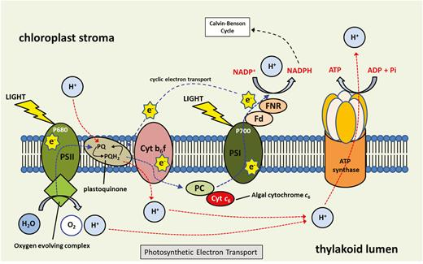
Schematic representation of photosynthetic electron transport. Ferredoxin (Fd), ferredoxin-NADP reductase (FNR), cytochrome b₆f complex (Cyt b₆f), plastocyanin (PC), cytochrome c₆ (Cyt c₆).

The cytochrome b₆f complex

The Cyt b₆f complex is a central component of photosynthetic electron transport and is located in the thylakoid membrane where it acts in both cyclic and linear electron transport mediating electron flow between PSII and PSI, providing ATP and NADPH for photosynthetic carbon fixation by oxidizing PQH₂, and reducing plastocyanin.

Lecture 5. Respiration and Its Functions

Respiration is an important biochemical process that produces ATP by oxidizing organic substrates. In annual and perennial crops, about 30–60% of the carbon assimilated during photosynthesis is lost through respiration.
This percentage may increase with rising global temperatures according to the data presented by our group, that is, respiration is positively correlated with temperature in the physiological temperature ranging from 0 to 38°C lant respiration is being studied in increasing depth and scope because of its importance for plants, the global atmosphere, and climate change. Despite intensive research, we still need to learn more about the factors that control the process, especially at larger scales. This ubiquitous process has essential applications in agriculture, climate action, and ecosystem management.
Plant respiration occurs in all plants, and there are two kinds: aerobic and anaerobic.

Aerobic respiration occurs in all green plants and uses oxygen to burn photosynthates (glucose and starch). It occurs partly in the mitochondria of the cells and all parts of the plant, shoot, and roots. The results of this process are carbon dioxide (CO2) and chemical energy in the form of Adenosine triphosphate (ATP), see equation 1. The steps involved are
- Glycolysis,
- The tricarboxylic acid (TCA) cycle or Citric Acid cycle,
- Mitochondrial electron transport chain
- Production of CO2 and Adenosine triphosphate (ATP).
Anaerobic respiration or fermentation occurs without oxygen and can also happen in higher-green plants. It also involves using glucose and starch in glycolysis but then follows another pathway to produce ethyl alcohol and lactic acid.
Besides producing energy, aerobic respiration has two other functions that must be considered.
Produce C precursors: Plants produce all the organic compounds they need by integrating inorganic compounds like nitrates or minerals. The basic compounds they start with are byproducts of the carbon metabolism in the glycolysis or Citric Acid Cycles. These byproducts act as building blocks and are called carbon skeletons or biosynthetic precursors.
Redox balancing: The mitochondrial electron chain, which produces electrons, is essential to balance oxidation-reduction or redox reactions in cellular processes, such as photosynthesis and neutralizing reactive oxygen species.
The three functions could overlap, but they need different modes of the respiration pathway, and plants have to coordinate them.

Scales of respiration
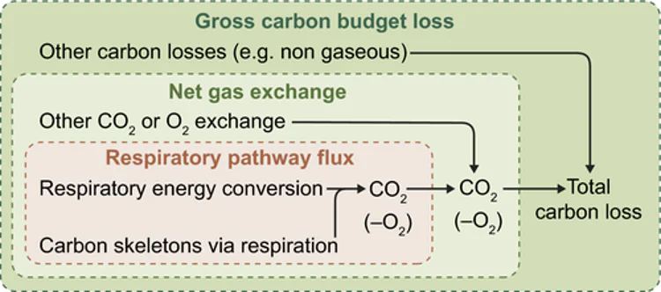

Tissue-level respiration processes describe the gas exchange that occurs through stomatal conductance within the tissues. The intake of oxygen from the atmosphere and the fate of CO2 produced is important here. Although not all the CO2 a plant produces is released into the atmosphere, at least part of it is used for photosynthesis during the day.
Plant-level respiration that considers the carbon budget of the plant. Here respiration is explained as carbon loss (see Equation 2) and includes shoot and root processes like photosynthesis, root exudation, biomass accumulation, etc. Here the results of respiration, like growth and maintenance, are essential.
Respiration = photosynthesis − plant biomass production Equation 2
This approach separates different aspects of respiration and is explained in Figure 1.
Respiration is not uniform, and the rate will vary based on environmental conditions and intrinsic factors. Considering that different factors influence respiration rates, let’s explore the three scales.

Lecture 6 Environmental factors affecting crop productivity
The environmental factors affecting crop yields can be classified into abiotic and biotic constraints. Actually, these factors are more intensified with global warming which leads to climate change. Abiotic stresses adversely affect growth, productivity and trigger a series of morphological, physiological, biochemical and molecular changes in plants. The abiotic constraints include soil properties (soil components, pH, physicochemical and biological properties), and climatic stresses (drought, cold, flood, heat stress, etc.). On the other hand, biotic factors include beneficial organisms (pollinators, decomposers and natural enemies), pests (arthropods, pathogens, weeds, vertebrate pests) and anthropogenic evolution.

Abiotic constraints
Effects of climatic conditions on crops

The regression analysis model between historical climatic data and yield data for food crops over the last 30 years in Nepal showed an increase in temperature of approximately 0.02–0.07°C per year in different seasons and a mixed trend in precipitation. Additionally, no significant impact of climate variables on yields of all crops was observed and the regression analysis revealed negative relationships between maize yield and summer precipitation, between wheat yield and winter minimum temperature, and finally positive relationship was observed between millet yield and summer maximum temperature.

Drought
Drought refers to a situation in which the amount of available water through rainfall and/or irrigation is insufficient to meet the evapotranspiration needs of the crop [16]. Climate change is driven by changes in water availability (volumes and seasonal distribution), and in water demand for agriculture and other competing sectors. The impending climate change adversities are known to alter the abiotic stresses like variable temperature regimes and their associated impacts on water availability leading to drought, increased diseases and pest’s incidence and extreme weather events at local to regional scale [16]. Moisture or drought stress accounts for about 30–70% loss of productivity of field crops during crop growth period [16]. Drought stress can induce abscisic acid (ABA) accumulation in guard cells to trigger stomatal closure [17]. Drought also results in abnormal metabolism that may reduce plant growth, and/or cause the death of entire plant. Drought has different effects at different stages of plant growth with the most sensitive growth stage being flowering period.
Lecture7. Theme Major Traits Contributing to Drought Resistance
Plant Traits and Mechanisms of Drought Adaptation
Drought adaptive traits
Primary traits |  |  | Secondary traits | Integrated traits
Constitutive traits | Induced traits
Roots |  | Osmotic changes | Relative water content | Drought sensitivity index
Phenology |  | Cell viability | Leaf senescence | Drought tolerance efficiency
Vaxes |  | Membrane integrity | Leaf folding/rolling | Harvest index
Stomatal conductance |  | Chlorophyll stability | Flowering time  Delayed senescence | Recovery growth
Water use efficiency |  | Protein synthesis |  | Plant height
 |  | Scavenging system |  | Leaf area
 |  | Lipid peroxidation |  | Growth parameters
 |  | Gas exchange

Early Flowering and Drought Escape
The molecular control of flowering time is complex, and has been highly studied in Arabidopsis ) as well as in many other plant species.
During the developmental switch from the vegetative to the reproductive stage, the photoperiodic light signal from the environment is perceived by leaves, where the FLOWERING LOCUS T (FT) protein is synthesized. FT is loaded into the phloem and transported to the shoot apical meristem (SAM) where it initiates floral transition. It is now known that in the SAM, FT forms a complex with the bZIP protein FD in specific cells beneath the tunica layers in which FD is expressed, with these cells then originating the floral primordia.
When Arabidopsis is exposed to drought conditions, it can activate the DE response. DE is one of the main defense mechanisms against drought in Arabidopsis, and it integrates the photoperiodic pathway with drought-related ABA signaling. DE has mainly been studied in an evolutionary context in natural populations, and the molecular mechanisms that regulate it have only been unraveled recently. It is known that, to trigger DE, the key photoperiodic gene GIGANTEA (GI) needs to be activated by ABA). A recent breakthrough was the discovery that the ABRE-BINDING FACTORS (ABF) 3 and 4, which act on the master floral gene SUPPRESSOR OF OVEREXPRESSION OF CONSTANS1 (SOC1) in response to drought, are involved in this process. The mutants abf3 abf4 are insensitive to ABA-induced flowering and have a reduced DE response. However, the precise molecular mechanisms that link ABA to GI and ultimately to DE are still rather obscure, and different crop species might have evolved unknown pathways that trigger DE in different environments
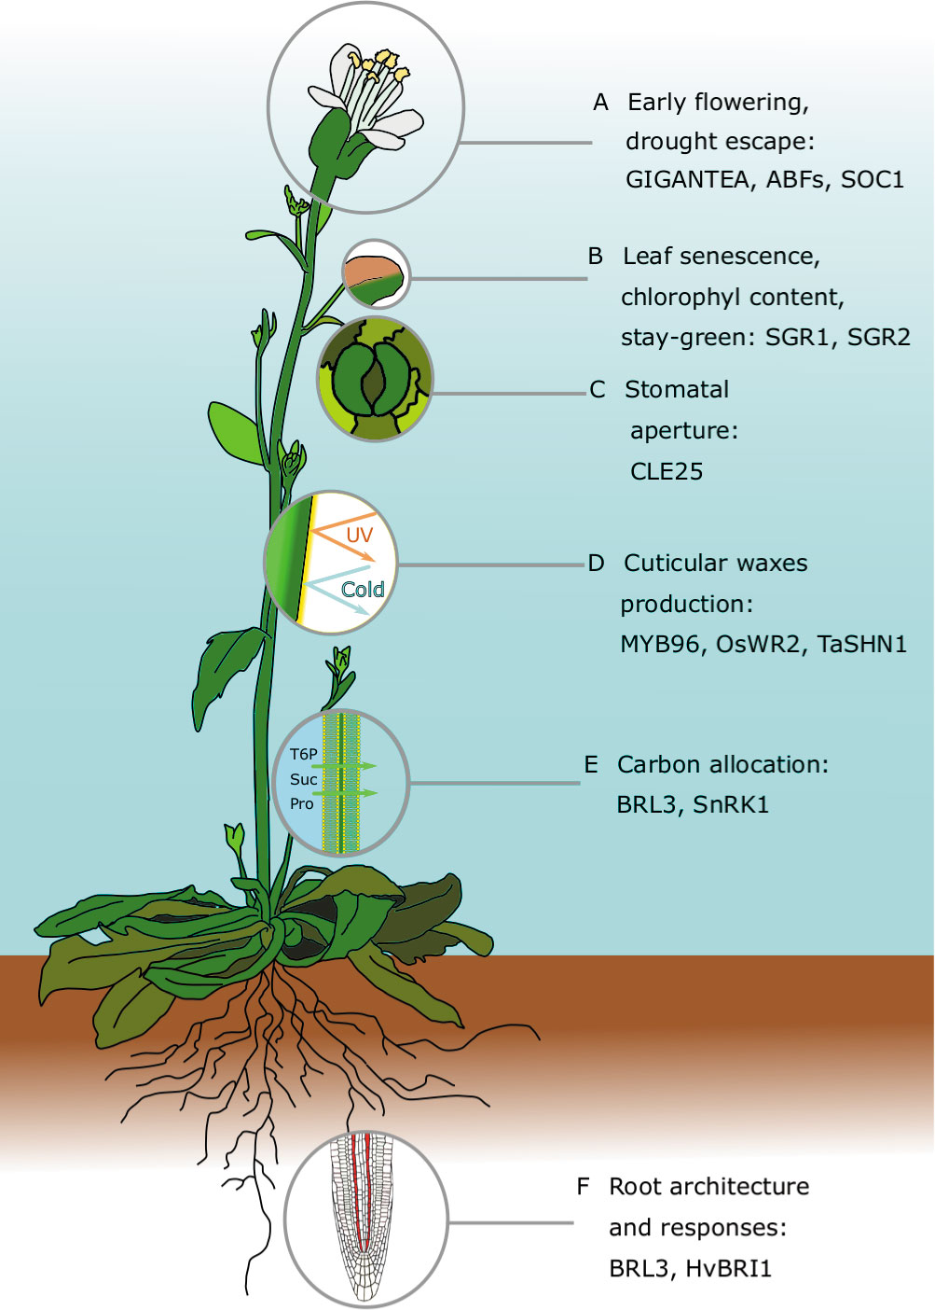
FIGURE 1 Major traits contributing to drought resistance in Arabidopsis thaliana: For each of the traits, we highlight recent and comprehensive review papers, and prominent articles discussed in the main text. (A) Early flowering and drought escape:

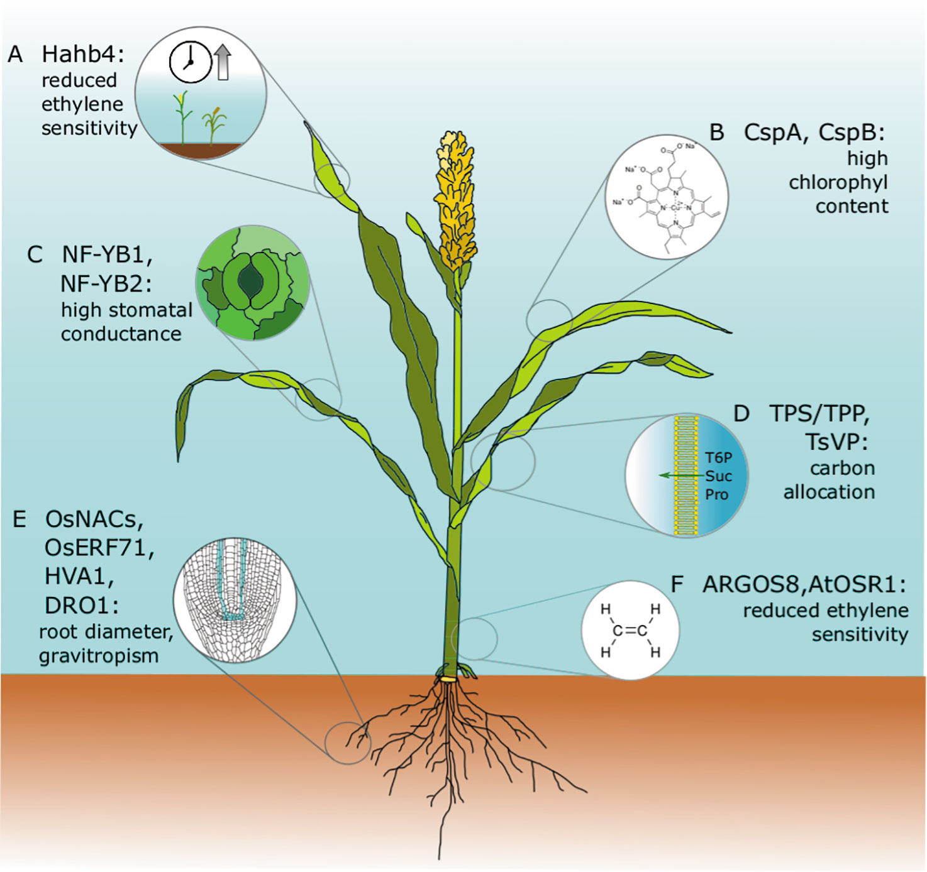

FIGURE 2 Drought tolerance genes that have been discovered or tested in model species and translated successfully into crop species. All of these genes have been expressed in engineered cereal crops and have been tested in field trials. Major agronomical traits, including yield, have been assessed, and conditions and drought performances have been successfully improved without negatively affecting plant growth or crop yield.

Lecture 8. Effect of Cold stress and Soil properties on crop productivity
Cold or chilling stress experiences by plants from 0 to 15°C, leads to major crop losses. Various types of crops in tropical or subtropical origin are injured or killed by non-freezing low temperatures, and exhibit different symptoms such as poor germination, stunted seedlings, chlorosis, or growth retardation, reduced leaf expansion and wilting and necrosis. In general, plants respond with changes in their pattern of gene expression and protein synthesis when exposed to low temperatures. In general, plants from temperate climatic regions are considered to be chilling tolerant with variable degree compare to tropical and sub-tropical crops, and can increase their freezing tolerance by cold acclimation

Soil properties
Soils are the uppermost part of the earth’s crust, formed mainly by the weathering of rocks, formation of humus and material transfer. They vary in terms of origin, appearance, characteristics and production capacity. Soil fertility is the ability of a soil to deliver nutrients needed for the optimum growth of a specified crop. Soil fertility is one of the most important factors in crop production. It has the ability to support crop production determined by the entire spectrum of its physical, chemical and biological attributes. Soil fertility is one important aspect of soil productivity since it is a major source of micronutrients (Fe, B, Cl, Mn, Zn, Cu, Mo, Ni) and macronutrients (N, P, K, Ca, S, Mg, C, O, H) that are needed for plant growth. The lack of these nutrients in the soil causes deficiencies in plants, and their excess leads to toxicities, which have negative impacts on crop yields.
Several parameters can be used to determine the fertility status of a soil. Among them, the soil fertility index was found to be the most useful indicator that helps to improve sustainable land use management and achieve economical yield in crop production. In several regions in the world, some croplands have undergone human-induced soil degradation resulting in poor yield production per unit area of crop harvest. Around 40% of agricultural lands are affected by human induced land degradation. Intensive agricultural production characterized by overuse of fertilizers and chemicals without adherence to agricultural sustainability leads to a decline of soil health, land degradation and severe environmental problems. It is important to note that the deterioration of soil fertility normally takes pace over several years.

Lecture 9. Effect of soil salinity, Floods and acidity stress on crop productivity

Salinity stress affects crop production in over 30% of irrigated crops and 7% of dry land agriculture worldwide. It is one of the major problems affecting crop production all over the world since around 20% of cultivated land and 33% of irrigated land are salt-affected in the world [30]. Salt causes osmotic stress and ionic toxicity in crop plants. Under normal conditions, the higher osmotic pressure in plant cells permits the absorption of water and essential nutrients from a soil solution into the root cells. However, under salt stress conditions, the high concentration of salts in the soil solution prevents absorption of water and essential minerals but will facilitate the entry of Na⁺ and Cl⁻ ions into the cells, which will have direct toxic effects on cell membranes as well as on metabolic activities in the cytosol.
Acidity stress. Low soil pH increases as a result of release of acidifying aluminum, iron and manganese ions, leaching of base ions such as calcium, magnesium, potassium and sodium, decomposition of soil organic matter and regeneration of organic acids, nitrification of ammonia-based fertilizers] as well as land management practices. Low soil pH significantly affects crop growth and therefore decreases yield. In maize for instance, soil acidity causes yield loss of up to 69%.
Floods Essentail different stressful conditions to plants, mainly depending on water depth and its duration. Soil waterlogging damages most crops, with the exception of rice, which like other wetland species thrives when plants are not completely submerged. In view of the changing climate, flooding has become frequent in many lowlands and cultivated areas every year and causes a lot of damage to human beings including losses in crop yields and food stuffs.
Flooding usually occurs with heavy rainfall, poor soil drainage and poor irrigation practices. Soil waterlogging has negative impacts on crop production especially for dryland species (such as most cereals, legumes, tubers, etc.) which include several crops. The excess water results in complex changes in plant physiology for non-adapted crops. This leads to restriction of gas diffusion between the plant and its surroundings (accumulation of high CO₂ and ethylene in the root zone with very low O₂), hypoxia (oxygen levels limit mitochondrial respiration) and anoxia (respiration is completely inhibited), often accompanied by increased of mobilization of ‘phytotoxins’ in reduced soils, leading to poor root metabolism (inability to absorb nutrients), lack of energy within plant cells, restriction of photosynthetic activities and therefore poor growth or death of plant roots and shoots.
The first constraint for plant growth under flooding conditions is the immediate lack of oxygen necessary to sustain aerobic respiration of submerged tissues [35, 36, 37]. As the duration of flooding increases, there is progressive decrease in soil reduction-oxidation potential (redox potential) (Figure 2). Flooding events can be classified by two categories: waterlogging where only the root system inside the soil is affected; and submergence, where also parts or the whole shoot are under water. In tree species with different flooding sensitivity, the importance of root-to-shoot transport of metabolites to ‘use rather than lose’ is a relevant criterion used to identify the tolerant species. Only non-wetland plants can survive flooding for a short period of time. The two survival strategies to flooding are plant avoidance of oxygen deficiency in tissues and the adaptation to oxygen deficiency.
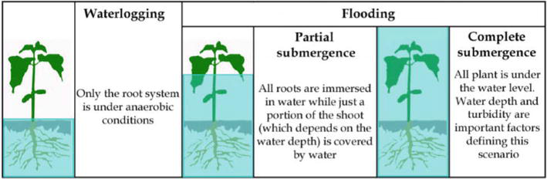

Figure 2. Different levels of excess of water in crop environment.

Lecture 10. Theme.. Genetic engineering strategies for abiotic stress tolerance. Drought and salinity tolerance Eeffect
The potential for improving yield through single and multigene manipulation of different processes in photosynthesis has been clearly demonstrated. The area for improving crops productivity are the following:

- Simultaneous manipulation of the Calvin–Benson cycle and photorespiration
- Multitarget manipulation of photosynthetic carbon assimilation
- Improving the efficiency of responses to the fluctuating light environment
- The dissipation of excess energy through non-photochemical quenching
- Redox regulation of photosynthesis

MODULE 3 Title Biotic factors affecting crop yields

Lecture 11. Theme...Improvement of plants productivity under different kind of diseases

Crop Diseases: Types, Control, And Prevention
Plant diseases are a severe threat to the entire production. Therefore, it is essential for farmers to effectively deal with them and check them with the help of timely prevention. Depending on the agricultural area size, this task can be difficult, especially since the list of harmful crop diseases is quite impressive. Modern technologies come to the aid of farmers. EOSDA Crop Monitoring allows you to identify dangerous areas and apply an individual approach to yield treatment, significantly increasing disease control effectiveness.
Unfavorable environmental conditions often generate non-communicable diseases. Examples are low or high temperature, excess, or lack of moisture. Also, diseases are usually caused by harmful impurities in the air. They can accumulate due to the presence of nearby chemical or metallurgical plants. Usually, the unhealthy physicochemical composition of the soil is the disease source.
The latter factor is often the result of poor-quality treatment of fields with some herbicides. These examples prove the importance of sustainable agriculture not only for protecting the environment but also for a profitable business.
Even an unfavorable light regime can cause negative consequences, especially for plants produced in greenhouses. Toxins that some embryophytes (higher plants) and fungi release into the soil can also be causal agents of crop diseases.
Infections’ causal agents include:
- bacteria;
- viruses;
- fungi;
- nematodes;
- parasitic plants.

Crop Diseases Caused By Bacteria Symptoms Of Bacterial Crop Diseases
The main bacterial disease indications include vascular wilting, necrosis, soft rot and tumor.

Although this type of plant disease can be identified due to its pronounced symptoms, identifying a specific causal agent requires laboratory methods Common Bacterial Diseases
As noted earlier, due to a huge number of bacteria, there are many disease types. Here are some examples of the most common diseases of crop plants:
- Granville wilt exposes itself in growth retardation, wilting of the high culture’s part, and the death of roots.
- Fire blight symptoms include necrotic weeping ulcers, wilting and rolling of leaves, while the dried parts of a plant do not fall off.
- Wildfire of tobacco is widespread in the world and shows itself as yellowish-green spots on leaves.
- Crop Diseases Caused By Fungi
Pathogenic fungi are the most typical agricultural problem. According to research, this plant disease type destroys about a third of all food crops every year. In this regard, this problem is severe both from a humanitarian and economic point of view. Like bacterial crop diseases, these infections affect plants mainly through wounds, stomata, and water pores. Also, fungal spores are often carried by gusts of wind.
Symptoms Of Fungal Crop Diseases
Often, a fungal infection is expressed in local or general necrosis. Also, crop diseases caused by fungi can interfere with the average growth or contribute to its abnormal burst, called hypertrophy. Other crop diseases symptoms include:
• spots on leaves;
• exfoliation;
• rot;
• anthracnose;
• ulcers;
• curls of leaves and warts.

Lecture 12. Theme. Mechanisms of improvement of plants productivity at pests

Pests are organisms that feed on and destroy or damage crops in the field or in storage.
Examples of pests are insects, birds, and rats There are two types of pests, namely:
Field pests and Storage pests.
Field pests
They attack the crops that are still growing or waiting to be harvested in the field or shamba.
Pests affect crops in the following ways:
1. They lower or reduce harvest.
A lower yield or a loss may be brought about by mature or stored crop or harvest being eaten by pests.
2. Reduced quality of produce for instance cereals with holes in them made by the weevils.
Such grains have a lower weight and mass since some of their parts have been eaten.
3. Pests that suck plant juices transmit diseases from unhealthy plants to healthy plants.
The infected plant may then die or produce a lower yield.
4. Diseases may also be transmitted to consumers from the plants that are infested by pests.
For instance, the rotting bodies of weevils and other insects and the excreta of such pests as rats and cockroaches spoil stored food by introducing germs which may cause diseases in people who eat it.
The excreta of birds dropped on grain being dried in open air may lead to food poisoning to people who eat the grain.
Packed maize flour sometimes contain a lot of weevils, making it unfit for human consumption.
Screening techniques for pest and disease resistance
Field Screening
Green house screening

Lecture 13. Theme. Reactive oxygen species metabolism and antioxidant defense in Plants under Stress
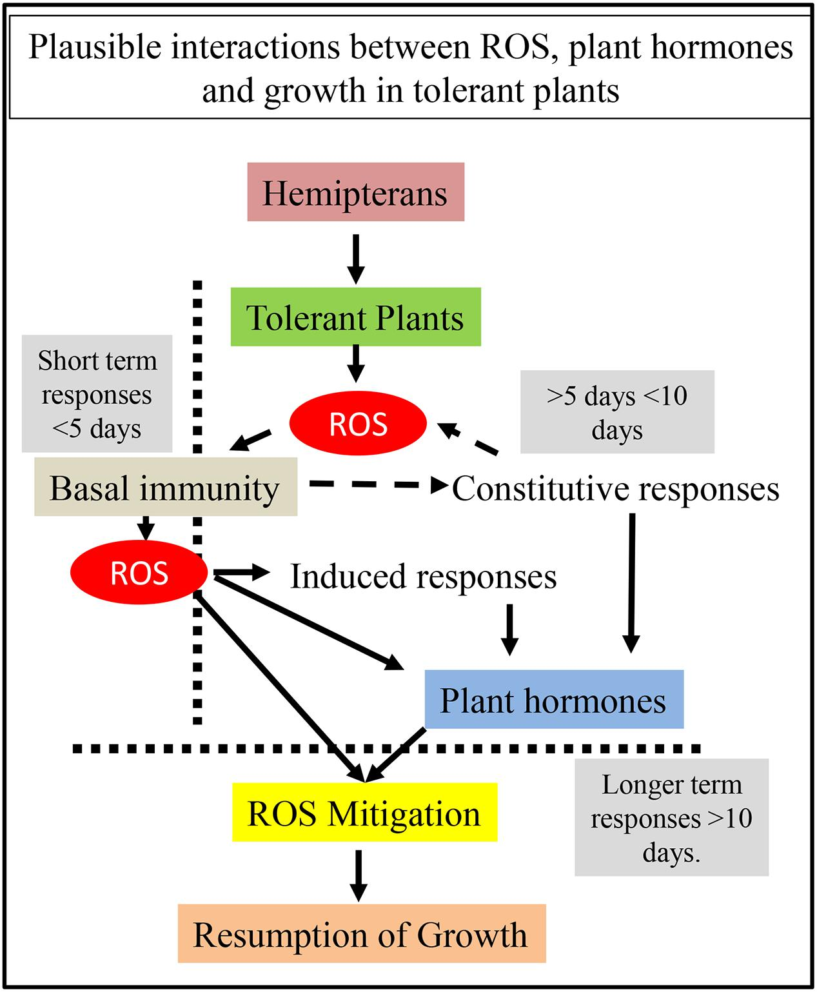 1. Predicted interactions between ROS and plant hormones during the tolerance response. Initial response to herbivory is through the generation of ROS and the activation of basal immunity. Potential interactions between basal immunity and genotypic-dependent constitutive responses are represented with broken black lines ending in arrows. These events take place within a few hours to a few days. More ROS is generated during this immune response leading to interactions with both the constitutive and induced responses in the plant. Both the induced and constitutive responses result in changes in plant hormones. ROS by itself and plant hormones trigger ROS mitigation, which leads to redox rebalancing. Redox rebalancing restores growth. Changes in plant growth have been normally reported as a longer term (>10 days) response. Whereas it is possible that early responses could control tolerance, it would seem more likely that cellular networks controlling plant hormone levels and ROS mitigation are more likely to underpin the tolerance response.

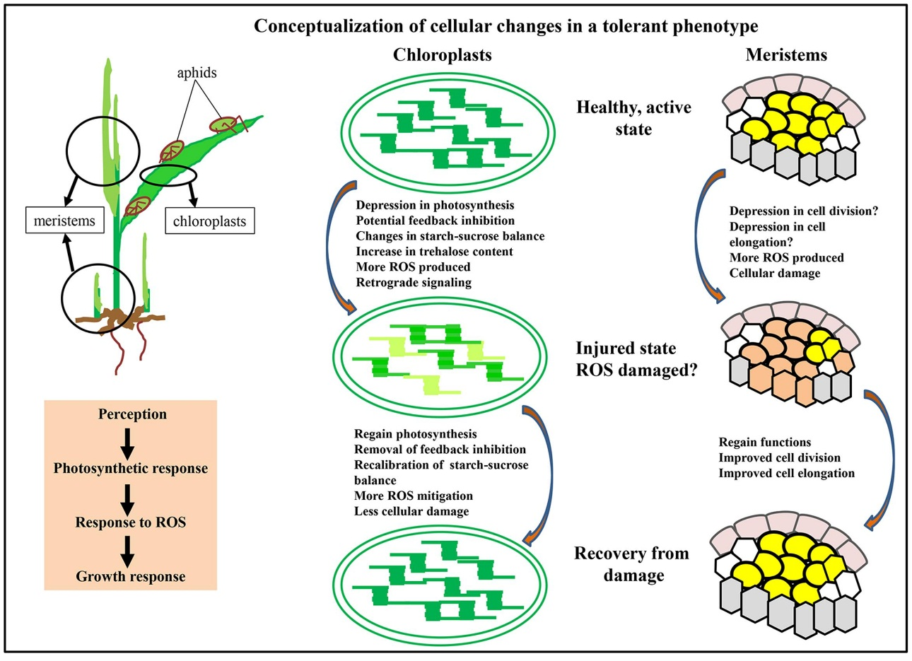

Conceptualization of cellular changes in a tolerant phenotype. Initial aphid probing of leaves, followed by continued feeding leads to multiple plant responses. Initial perception of the pest is accompanied by a photosynthetic response in the chloroplasts, and mitigation of ROS that is likely to involve a number of cellular compartments. A consequence of these physiological changes is a repression of growth of meristems. As physiological processes return to normal, growth is reinitiated. Within chloroplasts, these changes are represented as change from dark green to light green to denote loss of functions, and from light green to dark green to indicate recovery of functions. Similarly, in the apical meristems, orange colored cells indicate a stressed state and the other colors indicate a healthy state.

Lecture 14. Theme. Marker assisted selection in crop plants

Marker-assisted selection (MAS) is the process of using morphological, biochemical, or DNA markers as indirect selection criteria for selecting agriculturally important traits in crop breeding.

Genetic mapping of major genes and quantitative traits loci (QTLs) for many important agricultural traits is increasing the integration of biotechnology with the conventional breeding process. Exploitation of the information derived from the map position of traits with agronomical importance and of the linked molecular markers, can be achieved through marker assisted selection (MAS) of the traits during the breeding process. However, empirical applications of this procedure have shown that the success of MAS depends upon several factors, including the genetic base of the trait, the degree of the association between the molecular marker and the target gene, the number of individuals that can be analyzed and the genetic background in which the target gene has to be transferred. MAS for simply inherited traits is gaining increasing importance in breeding programs, allowing an acceleration of the breeding process. Traits related to disease resistance to pathogens and to the quality of some crop products are offering some important examples of a possible routinary application of MAS. For more complex traits, like yield and abiotic stress tolerance, a number of constraints have determined severe limitations on an efficient utilization of MAS in plant breeding, even if there are a few successful applications in improving quantitative traits. Recent advances in genotyping technologies together with comparative and functional genomic approaches are providing useful tools for the selection of genotypes with superior agronomical performancies.

MAS for drought stress tolerance
Drought is by far the most significant environ Imental stress in worldwide agriculture. Although plants are exposed to many types of environmental stresses, osmotic stress, whether by drought, salinity or low temperature, constitutes the most serious limitation to plant growth, productivity and distribution. Many studies on drought resistance have monitored the physiological and biochemical status of stressed plants compared with unstressed plants. Important mechanisms of drought resistance deduced from these studies mainly include the following: – drought escape via a short life cycle, photoperiod sensitivity and developmental plasticity; – drought avoidance via enhanced water uptake and reduced water loss; – drought tolerance via osmotic adjustment (OA) and antioxidant capacity; and – drought recovery via desiccation tolerance (Zhang et al., 1999). Direct selection for grain yield under water-stressed conditions is difficult due to low heritability and significant G x· E interactions.
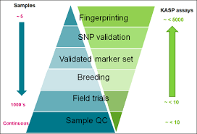

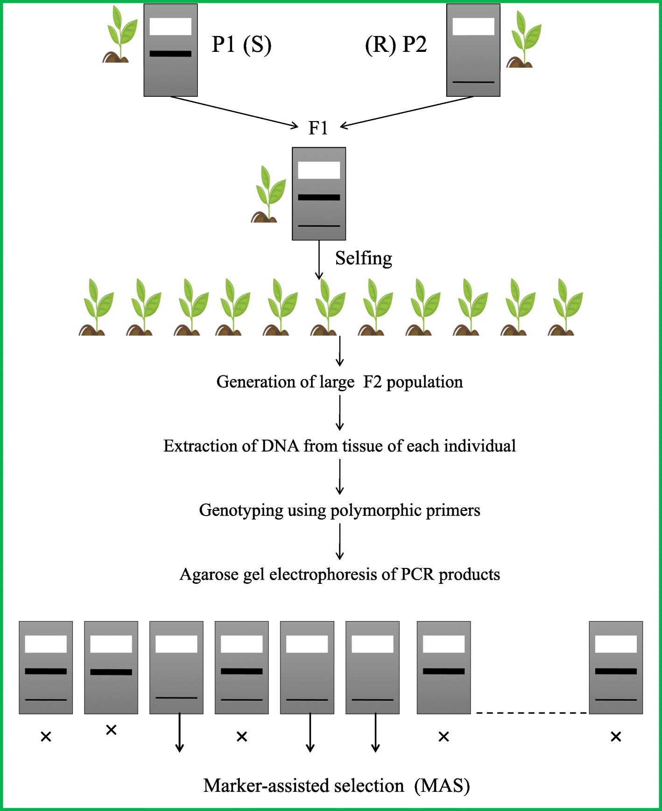
The figure explains the basic procedure of marker-assisted selection
Lecture 15. Theme... Strategies to overcome crop yield reduction. Development of new adapted crop genotypes
Breeding is conducted to increase levels of durable resistance to specific pests, diseases and different abiotic stresses using conventional crop improvement methods. However, there is now an increased use of modern biotechnology techniques such as marker-assisted selection, and transgenic approaches that involve genetic modification and high-throughput sequencing of both plant and pathogenic micro- organisms. Attempts have also been made to utilize transgenic technologies to build intrinsic tolerance mechanisms by the plants through alteration of functional genes]. Sustainable technologies like classical breeding approaches and integrated farming principles are also being considered to develop crops adaptation and/or enhance the adaptive mechanisms.
Under stress conditions, crop plants have evolved a set of perception and signal mechanisms to respond or adapt to adverse environmental conditions via regulation, transcription, gene expression, protein translation, modification, degradation, and metabolic regulation.
For example, strong associations were observed between the Na⁺ content and some metabolites, including several sugars, suggesting that metabolic regulation is important for plant responses to salinity stress. It has been demonstrated that manipulation of auxin biosynthesis pathway may improve crop plants tolerance to drought.
Physiological plant responses of crops to drought and heat stresses involve mechanisms to prevent membrane, regulate photosynthesis, respiration, and transpiration. For instance, developing crop genotypes with improved water used efficiency is one of the solutions to overcome drought stress. The most promising traits that might enhance crop flooding tolerance and facilitate longitudinal oxygen transport to sustain root aeration and water absorption in anaerobic soils, are anatomical adaptations such as formation of aerenchyma, a barrier against radial oxygen loss, and the growth of adventitious roots. The CBF/DREB1 genes are thought to be activators that integrate several components of the cold acclimation response by which plants increase their tolerance to low temperatures after exposure to non-freezing conditions. The DREB1/CBF genes have been successfully used to improve abiotic stress tolerance in a number of different crop plants [25].
The combination of genomics approaches such as marker-assisted selection (MAS) and genome wide associated studies (GWAS) can be efficiently used to develop biotic and abiotic stress tolerant cultivars (Figure 5). Future bio-computational integration of multiple omics and meta-omics with innovative research tools (reference genomes, proteomes, metabolomes with comprehensive annotations and structure–function relationships) will improve the understanding of the complexity of plant stress physiology] which will gather the development of the high-yielding and most adapted crop cultivars.
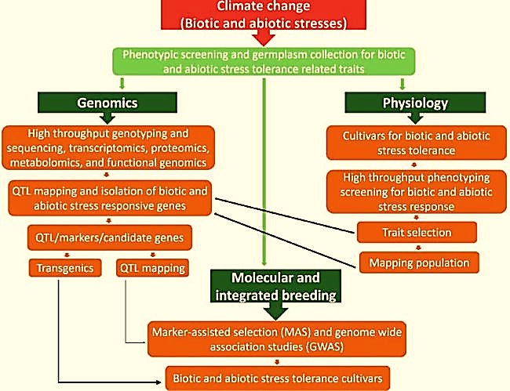

Figure 5. Different steps of applying combined biotechnological tools in the breeding for biotic and abiotic stress tolerant crop genotype

